FirstNet Website Structure

[git@github.com:esrgc/Firstnet.git](mailto:git@github.com:esrgc/Firstnet.git)

# Getting started

First net website is built with Node.js. It’s a remake of the original FirstNet Website at [https://mdinterop-public.sharepoint.com](https://mdinterop-public.sharepoint.com/). The site’s source code is on ESRGC’s GitHub. In order to make edits/changes to the site, please follow the steps below

1. Clone the repository on GitHub using the Url above.
2. Add/modify files.
3. Commit and push changes to Git.
4. Notify ESRGC server team about the changes, so the new changes will be pulled to the webserver.

# File Structure

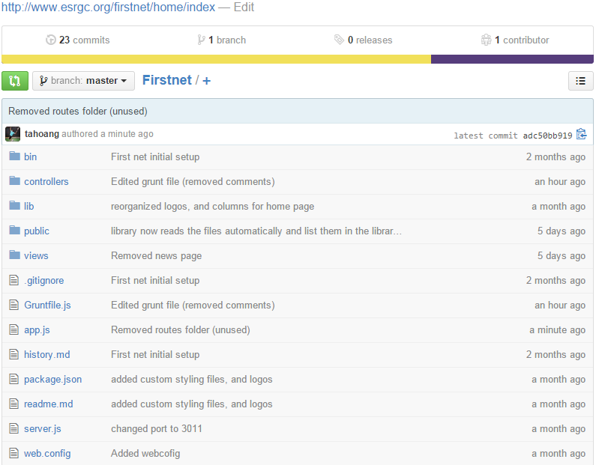

The site’s structure can be viewed on GitHub as above.

# Controllers

* Controllers folder contains js files that are run in node.js. The site is implemented in MVC (Model View Controller) convention, therefore, all server logic is implemented here in the controller files. For example, home.js is a controller that handles all home requests. Each request cooresponds with an action method written in this controller. In this case, Home only has one action method called “Index”, which handles request for the FirstNet home page <http://www.esrgc.org/firstnet/home/index>

The code for the this method is as below:

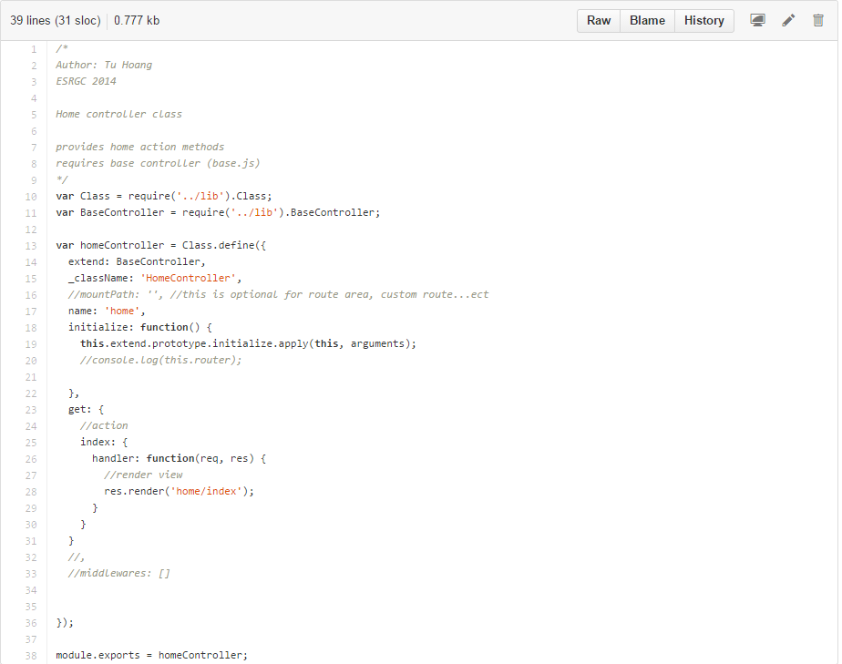This “index” action only returns a plain html page. So, all it does is rendering the view ‘home/index’ and return to the client. More details on views in “Views” section.

* In the code above, Index is the name of the action method, so it will form the route Home/index based on the controller name. Thus, the link <http://www.esrgc.org/firstnet/home/index> is formed.
* Each controller implements GET, POST, PUT, and DELETE methods. Each of these is declared in get, post, put, and delete objects accordingly. However, the site currently implements only GET methods at the time of this document preparation.

# Lib

* Lib folder is a custom package for node.js to implement MVC convention. The package is a wrapper of the router object in Express framework, which allows controllers’ methods to be mapped to specific routes. Please review the code for more details.

# Public

* This folder is the root of all static files including HTML, CSS, JavaScript files, and images.

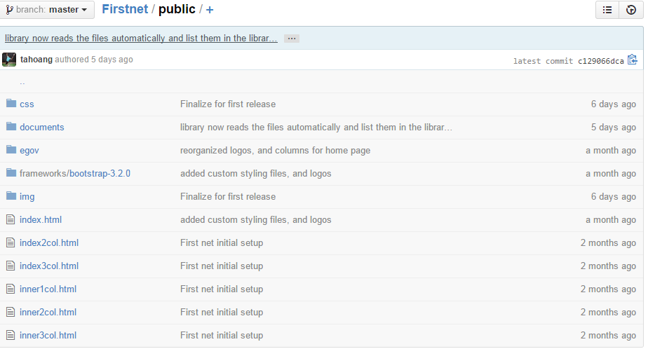

The cooresponding Url to this folder is <http://www.esrgc.org/firstnet>. Therefore, to request resources, simply use the root Url and add the resource name.

For example, to request the index.html file, use <http://www.esrgc.org/firstnet/index.html> (this is just a base template file, that was copied here for development purpose. This like is just to demonstrate how the static file is served).

# Public/documents

* This documents folder is a special folder. Its content is read by “library” controller action method in order to list the available documents on the Library page as below.

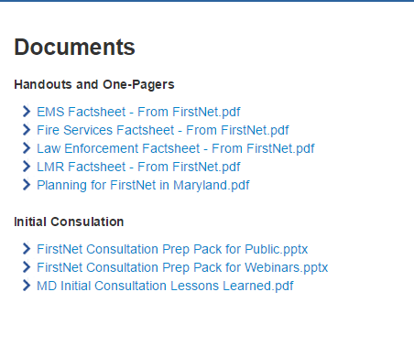

Listed documents available for download on Library page. Note that the file and folder names listed are exactly the same as the physical files and folders as shown below.

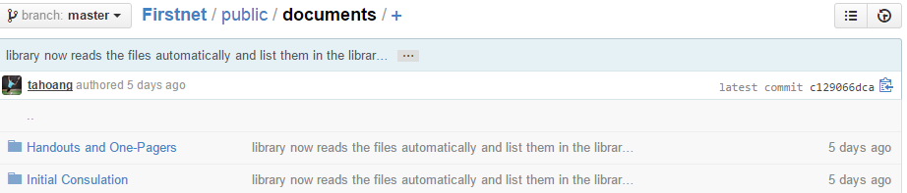

“Handouts and One-Pagers” folder.

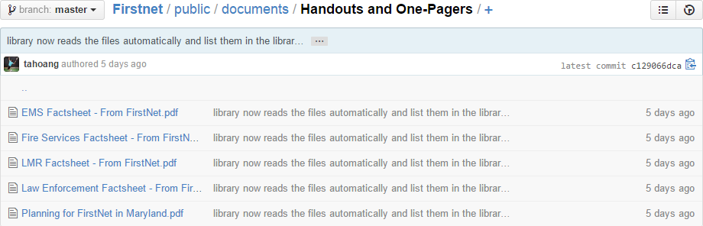

Note that only one level of sub-folder is allowed. Other folders in deeper levels will be ignored.

New document files can be added here by simply dropping new files/folders in and push a commit to Git. Once, a pull is done on the webserver, new files will be automatically listed in the “Library” page.

# Views

* All html views for the site are found here.

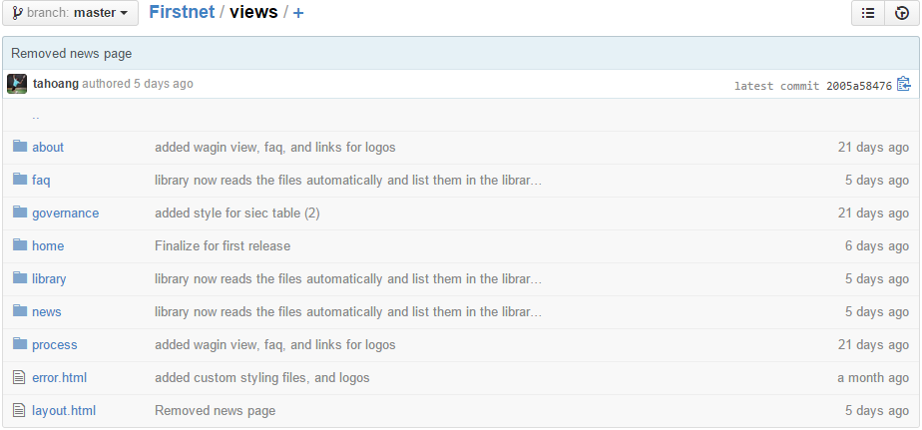

Each sub-folder contains views for specific controller as you see in the controller code, the render function parameter is the path to the view it’s rendering. For example, home folder contains all the views for home controller (res.render('home/index');), and library folder contains all the views for library controller (res.render('library/index', { model**:** library });).

* As FirstNet site uses template engine (EJS) and layout support for EJS (express-ejs-layouts), all views only specify the main content for pages. Other page content such as banners, header, footers…ect. are found in layout.html. This file is the main layout for all FirstNet web pages.
* Home.html (home page main content)

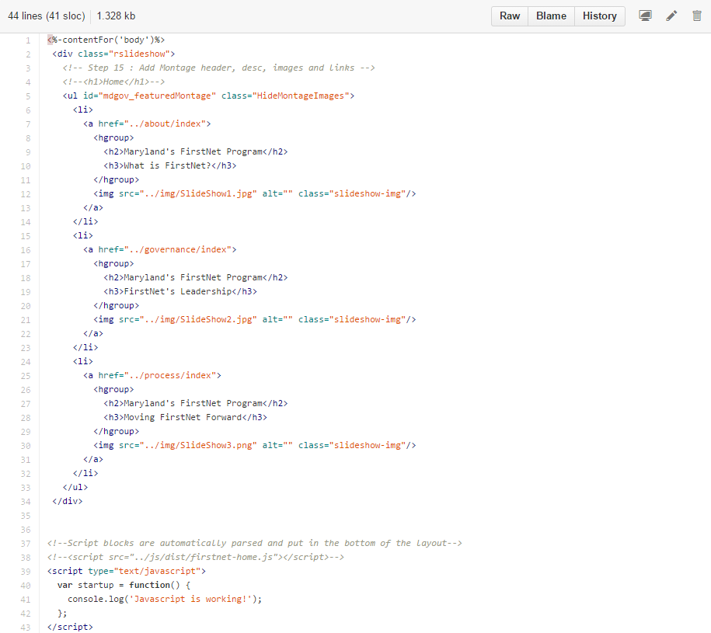

* <%-contentFor('body')%> This line of code in each view indicates that the content is for body section specified in layout.html as shown below.

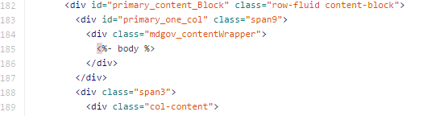

* To modify banner, header, footer, or anything that isn’t the main content, please use “layout.html” file. Changes made to this file will be displayed on all pages.
* For example, to add a new logo with a link to the footer section in layout.html, go to line 241 and add a new <li> tag with a new link and new logo image.

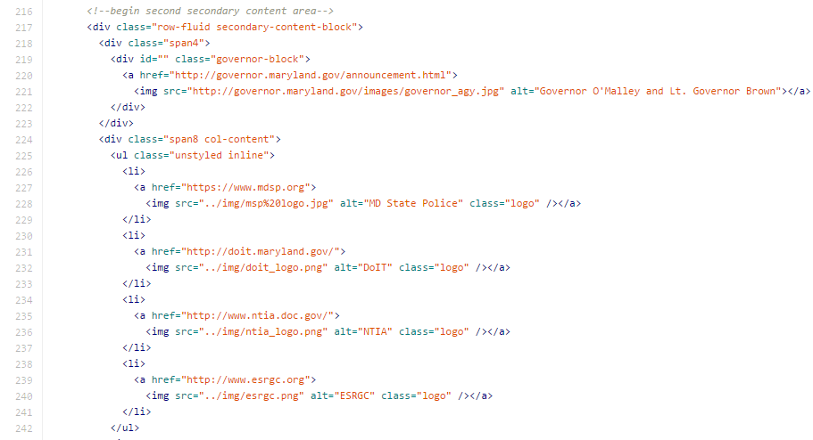

Note that all resources are located at root, therefore, the path “../img/esrgc.png” (full path http://www.esrgc.org/firstnet/img/esrgc.png) is used since all the site paths are as this Url template [http://www.esrgc.org/firstnet/{controller}/{action](http://www.esrgc.org/firstnet/%7bcontroller%7d/%7baction)}

# app.js

* This is the app initialization file, which specifies view engines and routes for the site.

# server.js

* In order to run the website, use “node server” in the command line in development, or run in a service for production.